**INFSCI 2710 Database Management, Fall 2024**

Consider a Hospital Management System. This system will manage patients, doctors, nurses, treatments, rooms and billing information:

1. Patient
   * + Each patient has a unique patient ID, name, date of birth, gender, contact details, and admission date.
     + Each patient can be assigned to a room and may receive one or more treatments.
     + Each patient will have a billing record based on treatments and room charges
2. Doctors
   * + Each doctor has a unique doctor ID, name, specialization, years of experience, and contact details.
     + A doctor can attend to multiple patients, and each patient can be attended by multiple doctors (many-to-many relationship).
3. Nurses
   * + Each nurse has a unique nurse ID, name, and shift details.
     + Nurses are assigned to rooms and assist patients.
4. Rooms
   * + Each room has a unique room ID, type (e.g., ICU, general), capacity, and availability status.
     + Patients are assigned to rooms, and each room may house multiple patients (up to its capacity).
5. Treatments
   * + Each treatment has a unique treatment ID, treatment name, and cost.
     + Patients receive treatments, which are administered by doctors.
6. Billing
   * + Billing is associated with each patient and includes the treatment cost and room charges.
     + Each billing record has a unique bill ID, patient ID, total amount, and billing date.

**Q1 [5 pt] What are the main entities and their attributes in this system? Identify primary keys for each entity.**

**SOLUTION:**

Main Entities and Their Attributes

1. **Patient**
   * Attributes:
     + Patient ID (Primary Key)
     + Name
     + Date of Birth
     + Gender
     + Contact Details
     + Admission Date
2. **Doctor**
   * Attributes:
     + Doctor ID (Primary Key)
     + Name
     + Specialization
     + Years of Experience
     + Contact Details
3. **Nurse**
   * Attributes:
     + Nurse ID (Primary Key)
     + Name
     + Shift Details
4. **Room**
   * Attributes:
     + Room ID (Primary Key)
     + Type (e.g., ICU, General)
     + Capacity
     + Availability Status
5. **Treatment**
   * Attributes:
     + Treatment ID (Primary Key)
     + Treatment Name
     + Cost
6. **Billing**
   * Attributes:
     + Bill ID (Primary Key)
     + Patient ID (Foreign Key)
     + Total Amount
     + Billing Date

**Q2 [5 pt] How would you represent the many-to-many relationship between patients and doctors in the database?**

**SOLUTION:**

To represent the many-to-many relationship between **Patients** and **Doctors**, a **relation table** is required. This table will capture the association between the two entities.

**Table: Attend**

* **Attributes**:
  + Patient ID (Foreign Key referencing the **Patient** table)
  + Doctor ID (Foreign Key referencing the **Doctor** table)
  + Interaction Date (optional, to record when a patient was attended by a doctor)

**Primary Key:**

* A composite primary key consisting of **Patient ID** and **Doctor ID** ensures the uniqueness of each relationship.

**Q3 [5 pt] How would you enforce room capacity limits in your schema design?**

**SOLUTION:**

**Patient**

* + Attributes:
    - Patient ID (Primary Key)
    - Name
    - Date of Birth
    - Gender
    - Contact Details
    - Admission Date

**Room**

* + Attributes:
    - Room ID (Primary Key)
    - Type (e.g., ICU, General)
    - Capacity
    - Availability Status

Relation between Patient and Room can be made through creating a table called **Assign_Room** table which contains the primary keys of **Patient** table and **Room** table.

**Assign_Room**

* + Attributes:
    - Patient ID (Foreign Key referencing the **Patient** table)
    - Room ID (Foreign Key referencing the **Room** table)

**Constraint:**

**Using Triggers:**

Create Trigger enforce_room_capacity

Before Insert On Assign_Room

For Each Row

Declare

current_capacity INT

room_capacity INT

Begin

Select Count(*)

Into current_capacity

From Assign_Room RA

Where RA.Room_ID = :NEW.Room_ID;

Select Capacity

Into room_capacity

From Room

Where Room_ID = :NEW.Room_ID;

If current_capactiy >= room_capacity Then

Raise_Application_Error(-20001, 'Room Capacity Exceeded');

End If;

End;

**Q4 [10 pt] Draw an ER diagram for the system above**

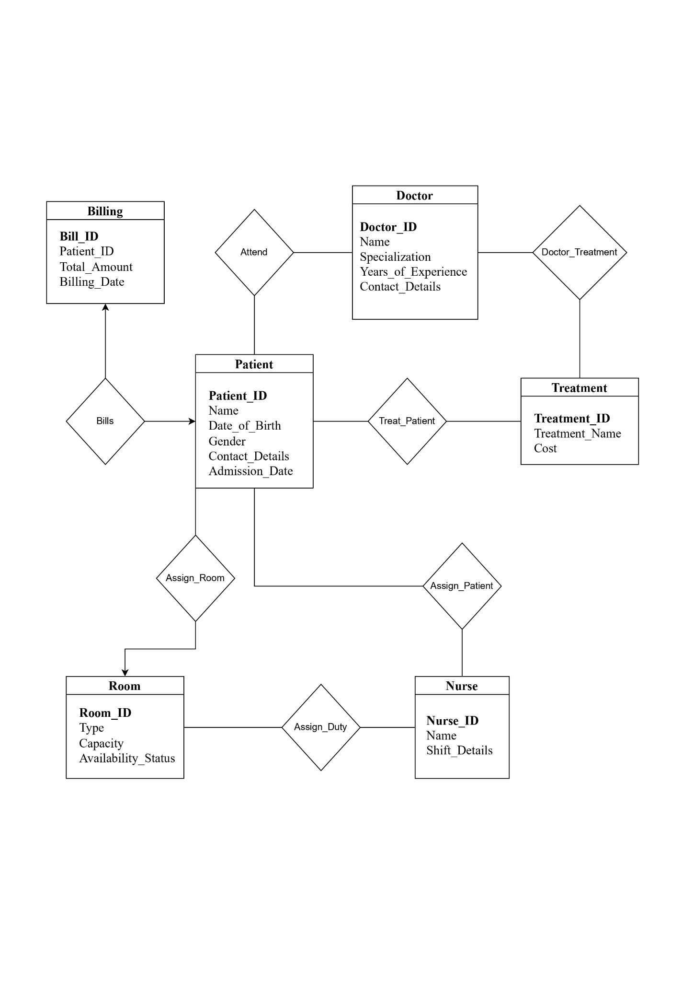

**Q5 [20 pt] Translate the ER diagram from Q4 into SQL DDL statements create table queries**

CREATE TABLE Patient (

Patient_ID INT PRIMARY KEY,

Name VARCHAR(100) NOT NULL,

Date_of_Birth DATE NOT NULL,

Gender VARCHAR(20) NOT NULL,

Contact_Details VARCHAR(255),

Admission_Date DATE NOT NULL

);

CREATE TABLE Doctor (

Doctor_ID INT PRIMARY KEY,

Name VARCHAR(100) NOT NULL,

Specialization VARCHAR(100),

Years_of_Experience INT,

Contact_Details VARCHAR(255)

);

CREATE TABLE Treatment (

Treatment_ID INT PRIMARY KEY,

Treatment_Name VARCHAR(100) NOT NULL,

Cost DECIMAL(10, 2) NOT NULL

);

CREATE TABLE Room (

Room_ID INT PRIMARY KEY,

Type VARCHAR(20) NOT NULL,

Capacity INT NOT NULL,

Availability_Status BOOLEAN NOT NULL

);

CREATE TABLE Nurse (

Nurse_ID INT PRIMARY KEY,

Name VARCHAR(100) NOT NULL,

Shift_Details VARCHAR(100)

);

CREATE TABLE Billing (

Bill_ID INT PRIMARY KEY,

Patient_ID INT,

Total_Amount DECIMAL(10, 2) NOT NULL,

Billing_Date DATE NOT NULL,

FOREIGN KEY (Patient_ID) REFERENCES Patient(Patient_ID)

);

CREATE TABLE Attend (

Patient_ID INT NOT NULL,

Doctor_ID INT NOT NULL,

PRIMARY KEY (Patient_ID, Doctor_ID),

FOREIGN KEY (Patient_ID) REFERENCES Patient(Patient_ID),

FOREIGN KEY (Doctor_ID) REFERENCES Doctor(Doctor_ID)

);

CREATE TABLE Assign_Duty (

Nurse_ID INT NOT NULL,

Room_ID INT NOT NULL,

PRIMARY KEY (Nurse_ID, Room_ID),

FOREIGN KEY (Nurse_ID) REFERENCES Nurse(Nurse_ID),

FOREIGN KEY (Room_ID) REFERENCES Room(Room_ID)

);

CREATE TABLE Assign_Room (

Patient_ID INT NOT NULL,

Room_ID INT NOT NULL,

PRIMARY KEY (Patient_ID, Room_ID),

FOREIGN KEY (Patient_ID) REFERENCES Patient(Patient_ID),

FOREIGN KEY (Room_ID) REFERENCES Room(Room_ID)

);

CREATE TABLE Assign_Patient (

Patient_ID INT NOT NULL,

Nurse_ID INT NOT NULL,

PRIMARY KEY (Patient_ID, Nurse_ID),

FOREIGN KEY (Patient_ID) REFERENCES Patient(Patient_ID),

FOREIGN KEY (Nurse_ID) REFERENCES Nurse(Nurse_ID)

);

CREATE TABLE Treat_Patient (

Patient_ID INT NOT NULL,

Treatment_ID INT NOT NULL,

PRIMARY KEY (Patient_ID, Treatment_ID),

FOREIGN KEY (Patient_ID) REFERENCES Patient(Patient_ID),

FOREIGN KEY (Treatment_ID) REFERENCES Treatment(Treatment_ID)

);

CREATE TABLE Doctor_Treatment (

Doctor_ID INT NOT NULL,

Treatment_ID INT NOT NULL,

PRIMARY KEY (Doctor_ID, Treatment_ID),

FOREIGN KEY (Doctor_ID) REFERENCES Doctor(Doctor_ID),

FOREIGN KEY (Treatment_ID) REFERENCES Treatment(Treatment_ID)

);

**Q6 [15 pts] Consider Table (a) which shows part of the records in relation R. Complete the table (b) for given functional dependencies (FD). Please just answer yes, no or unknown**

**Solutions:**

| **FD** | **Satisfied on given records**  **(yes/ no/unknown)** | **Hold on R (yes/no/unknown)** | **Trivial (yes/no)** |
| --- | --- | --- | --- |
| A→ B | No | No | No |
| B→ A | No | No | No |
| AC→ D | Yes | Unknown | No |
| AC→B | No | No | No |
| AD→ B | No | No | No |
| ABC→ AC | Yes | Yes | Yes |
| BC→ D | Yes | Unknown | No |
| C→ AC | No | No | No |
| AB→ A | Yes | Yes | Yes |
| BD→ A | No | No | No |

**Q7 [10 pts] Consider a relation R1(A,B,C,D,E,F,G) and a set of functional dependencies FD = {AB → E, C → D, DE → F, DA → G} which hold on R1. Using Armstrong's axioms verify if the following functional dependencies hold on R1**

| FD | Yes/No | Proof if yes |
| --- | --- | --- |
| AC → G | Yes | A → A (By Reflexivity)  C → D (Given)  AC → AD (By Union)  AD → G (Given)  AC → G (By Transitivity) |
| AC→ F | No | - |
| ABD→F | Yes | AB → E (Given)  ABD → ED (By Augmenting D)  DE → F (Given)  ABD → F (By Transitivity) |
| BCD→ F | No | - |
| ABC→EG | Yes | AB → E (Given)  ABC → AB (By Reflexivity)  ABC → E (By Transitivity)  ABC → C (By Reflexivity)  C → D (Given)  ABC → D (By Transitivity)  ABC → DE (By Union)  DE → F (Given)  ABC → F (By Transitivity)  DA → G (Given)  ABC → D (Derived from above)  ABC → DA (By Augmenting A)  ABC → G (By Transitivity)  ABC → E (Derived from above)  ABC → EG (By Union) |

**Q8 [10 pts] Consider a relation R(A,B,C,D,E,F) and a set of functional dependencies, which hold on R : { CD->BE, B->CA, D->F} Are decompositions in the table lossless and why?**

| Decomposition | Lossless?  (Yes) / (No) | Why |
| --- | --- | --- |
| R1(ABF) and R2(CDE) | No | R1 ∩ R2 - None  Since the intersection of R1 and R2 is none, the decomposition is not lossless. |
| R1(ABCEF) and R2(CDE) | Yes | R1 ∩ R2 - CE  **To Prove:**  CE → ABCEF  CE → CDE  **Proof: CE → ABCEF**  B → CA (Given)  D → F (Given)  BD → ACF (By Union)  CBD → ACF (By Augmenting C)  BE → ACF (By Given)  E → E (By Reflexivity)  BE → ACEF  B → C (Gives)  CE → ACEF  BCE → ABCEF (By Augmenting B)  **CE → ABCEF**  Hence Proved  **CE acts as a candidate key for R1**  **Proof: CE → CDE**  This is trivial for R2 and **CE acts as a candidate key for R2 as well**.  Therefore this is a **lossless decomposition.** |
| R1(ABDE) and R2(BDF) | Yes | R1 ∩ R2 - BD  **To Prove:**  BD → ABDE  BD → BDF  **Proof: BD → BDF**  D → D (By Reflexivity)  B → CA (Given)  BD → ACD (By Union)  CD → BE (Given)  BD → ABE (Substituted)  D → D (By Reflexivity)  BD → ABDE (By Union)  Hence Proved  **BD acts as the candidate key for R1**  **Proof: BD → BDF**  D → F (Given)  BD → BF (By Augmenting B)  D → D (By Reflexivity)  BD → BDF (By Union)  Hence Proved  **BD acts as the candidate key for R2**  Therefore this is a **lossless decomposition.** |
| R1(ACDF) and R2(BCDE) | Yes | R1 ∩ R2 - CD  **To Prove:**  CD → ACDF  CD → BCDE  **Proof: CD → ACDF**  CD → BE (Given)  CD → CD (By Reflexivity)  CD → BCDE (By Union)  CD → B (Gives)  B → CA (Given)  CD → CA (By Transitivity)  CD → ABCDE (By Union)  D → F (Given)  CD → ABCDEF (Substituted)  **CD → ACDF**  Hence Proved  **CD acts as the candidate key for R1**  **Proof: CD → BCDE**  CD → BE (Given)  CD → CD (By Reflexivity)  CD → BCDE (By Union)  **CD → BCDE**  Hence Proved  **CD acts as the candidate key for R2**  Therefore this is a **lossless decomposition.** |
| R1(ABEF) and R2(BCDF) | Yes | R1 ∩ R2 - BF  **To Prove:**  BF → ABEF  BF → BCDF  **Proof: BF → ABEF**  B → CA (Given)  BD → ACD (By Augmenting D)  BD → ABCD (By Reflexivity)  D → F (Given)  BF → ABCF (Substituted)  CD → E (Gives)  CF → BE (Gives)  BF → ABE (Substituted)  BF → ABCF  BF → ABCEF (By Union)  **BF → ABEF**  Hence Proved  **BF acts as the candidate key for R1**  **Proof: BF → BCDF**  B → CA (Given)  BD → ACD (By Augmenting D)  BD → ABCD (By Reflexivity)  D → F (Given)  BD → ABCF (Substituted)  BD → ABCDF  BD → BCDF  **BF → BCDF**  Hence Proved  **BF acts as the candidate key for R2**  Therefore this is a **lossless decomposition.** |

**Q9 [10 pts] Consider the following relations with the associated functional dependencies. Decide, whether those relations are in (a) BCNF, (b)3NF, (c) neither in BCNF nor 3NF normal form.**

| Relation, FD | Answer (a, b, or c) | Reason |
| --- | --- | --- |
| R1(A,B,C,D)  {AB→ C, C→ D} | **(c)** | **Keys:**  AB → AB (By Reflexivity)  AB → C (Given)  C → D (Given)  AB → D (By Transitivity)  AB → ABCD (By Union)  **AB is the candidate key**  **F1:**  (AB)Left part is candidate key so it is  good for BCNF  **F2:** C is not the candidate key so in order to  check for 3NF. Verify right part (D) which  is not the subset of the keys generated.  **Therefore R1 is neither BCNF nor 3NF.** |
| R2(A,B,C,D),  {AC→ BD} | **(a)** | **Keys:**  AC → AC (By Reflexivity)  AC → BD (Given)  AC → ABCD (By Union)  **AC is the candidate key**  **F1:**  (AC) Left part is candidate key so it is  good for BCNF  **Therefore R2 is in BCNF.** |
| R3(A,B,C,D)  {AB→ CD, D→A} | **(b)** | **Keys:**  AB → AB (By Reflexivity)  AB → CD (Given)  AB → ABCD (By Union)  **AB is the candidate key**  D → A (Given)  D → AD (By Union)  BD → ABD (By Augmenting B)  BD → ABCD (By derived)  **BD is the candidate key**  **F1:**  (AB) Left part is candidate key so it is  good for BCNF  **F2:**  (D) is not the candidate key so in order to  check for 3NF. Verify right part (A) which  is the subset of the keys generated. So, it is  good for 3NF.  **Therefore R3 is in 3NF.** |
| R4(A,B,C,D,E),  {AC→D, D→B} | **(c)** | **Keys:**  AC → AC (By Reflexivity)  AC → D (Given)  AC → ACD (By Union)  AC → B (By Transitivity)  AC → ABCD (By Union)  ACE → ABCDE (By Augmenting E)  **ACE is the candidate key**  **F1:**  (AC) is not the candidate key so in order to  check for 3NF. Verify right part (D) which  is not the subset of the keys generated.  **F2:** D is not the candidate key so in order to  check for 3NF. Verify right part (B) which  is not the subset of the keys generated.  **Therefore R4 is neither BCNF nor 3NF.** |
| R5(A,B,C,D,E)  {CD→ ABE, B→ C} | **(b)** | **Keys:**  CD → CD (By Reflexivity)  CD → ABE (Given)  CD → ABCDE (By Union)  **CD is the candidate key**  B → C (Given)  B → B  B → BC (By Union)  BD → BCD (By Augmenting D)  BD → ABCDE (By derived)  **BD is the candidate key**  **F1:**  (CD) Left part is candidate key so it is  good for BCNF  **F2:**  (B) is not the candidate key so in order to  check for 3NF. Verify right part (C) which  is the subset of the keys generated. So, it is  good for 3NF.  **Therefore R5 is in 3NF.** |

**Q10 [10pts] Draw a valid B+ tree below for the search keys (1, 2, 3, 4, …, 12). Assume the keys are inserted in their natural order. The order of the tree is 3**

